1.
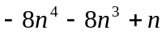

2.
When 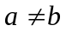, the intersection line is 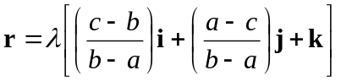,
When 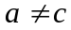, the intersection line is 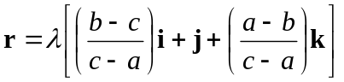

3.
Prove by mathematical induction.

4.
(i) 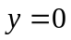 , 
(ii) Local minimum point : 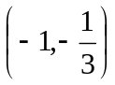

5.
(i)
(ii) 